SOLUTION DESIGN DOCUMENT

Project:
Label Printing & Dispatch Solution

Customer:
DAIICHI N HORIZON.

Submitted By:


NOTICE
This document contains information, which is the proprietary property of SATO. This document is received in confidence and its contents cannot be disclosed or copied without the prior written consent of SATO.
Nothing in this document constitutes a guaranty, warranty, or license, express or implied. SATO disclaims all liability for all such guaranties, warranties, and licenses, including but not limited to: Fitness for a particular purpose; merchantability; not infringement of intellectual property or other rights of any third party or of SATO; indemnity; and all others. The reader is advised that third parties can have intellectual property rights that can be relevant to this document and the technologies discussed herein, and is advised to seek the advice of competent legal counsel, without obligation of SATO
SATO retains the right to make changes to this document at any time, without notice. SATO makes no warranty for the use of this document and assumes no responsibility for any errors that can appear in the document nor does it make a commitment to update the information contained herein.

COPYRIGHT
Copyright © SATO 2019. All rights reserved.

TRADEMARKS
*Other product and corporate names may be trademarks of other companies and are used only for explanation and to the owners' benefit, without intent to infringe.
Document Revision History

Revision Number | Date | Prepared By | Comment
1.00 | December. 05, 2019 | Dipak Pathak | Original Document
1.01 | February. 25,2020 | Dipak Pathak | Original Document

Acronym
Customer: Daiichi N Horizon. hence forth will be referred as DNH.
Vendor: Sato Argox India Pvt. Ltd., hence forth will be referred as SATO.

Contents
PROJECT SCOPE 6
System Requirements 6
Desktop Computers 6
Development Tools 6
Introduction 6
Login Screen 7
Main Menu 8
Master Management 9
User Master 9
Group Master 10
Customer Master 11
Part Master 12
Revision Master 13
Process 14
Label Printing 14
Re-Printing 16
Create Picklist No. 17
HHT Upload Data 18
HHT Main Menu 19
Picking 20
HHT Download Picking Data 21
Dispatch (Kanban Verification) 22
HHT Download Dispatch Data 24
Web Reports 25
Login 25
Report Main Menu 26
Production Report 27
Dispatch Report 28
Lot Wise Dispatch Report 29
Balance Status Report 30

PROJECT SCOPE
The scope of the solution is to equip users with a Packing Label & Dispatch Validation Process, which can print barcode label and manage Packing Label & Dispatch Validation operation. This would require the development of the desktop application & device application will marry Kanban barcode. The document lays down the specifications of the middleware application, its architecture and infrastructure requirements.
The entire solution consists of followings:
- Front-End Application – Desktop Application
- Reporting Application – Web Application
- Mobile Device Application

The solution will work on client server environment; the data will be stored at data server.

System Requirements
This section provides the necessary details about the hardware components required by the solution.

Desktop Computers
The desktop application would require the computer with following specifications:-
- Intel Core i3 or better CPU
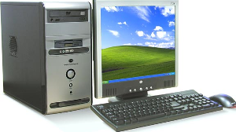
- Operating system - Microsoft Windows 7(Service Pack 1)/ Windows 10
- Hard Disk 40 GB or above
- Minimum 2 GB RAM
- Dot net Framework 4.0/4.5 Preinstalled
- USB Port

Development Tools
- Application User Interface: GUI C#.net 2015/2017
- Data Storage (DB): Sql Express 2014

Introduction
The scope of this document is to provide the understanding of this solution to all members of DNH Team & SATO Team associated with the solution development & implementation.
This document major emphasize on solution processes & user operations, where the data will be captured and afterwards will be used.
This solution major comprises of followings:
- Master Managements
- Different Types of Processes.

Login Screen
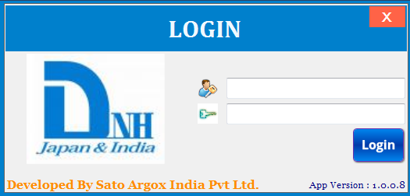

Brief Description: This screen is used for login purpose. User will enter User id & Password; system will validate entered user id & password from Application Database. On the basis of entered user id & user rights assigned to user, menus of Main Menu screen will be enabled.

Main Menu
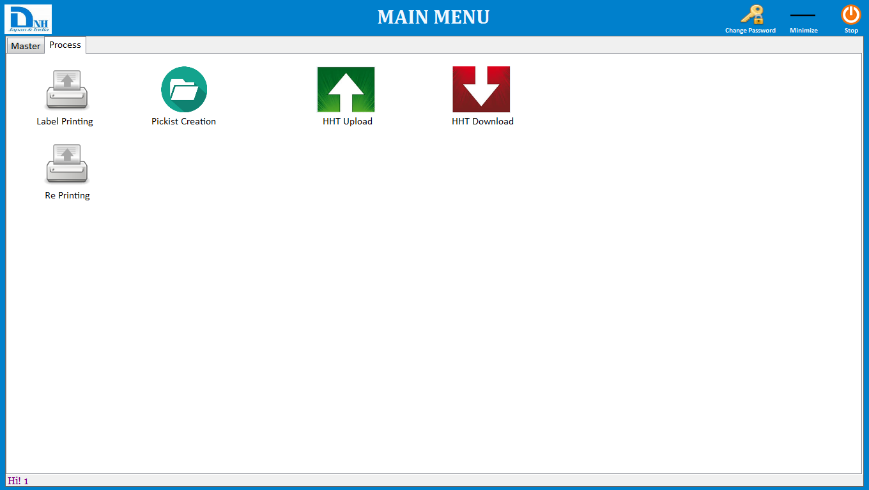

Brief Description: Main menu has two categories.
Master – By clicking on relative master menu user can navigate to different screen, like as user will click on User Master it will take to user master screen.

Process – By clicking on relative process menu user can navigate to different process screen.

Master Management

User Master
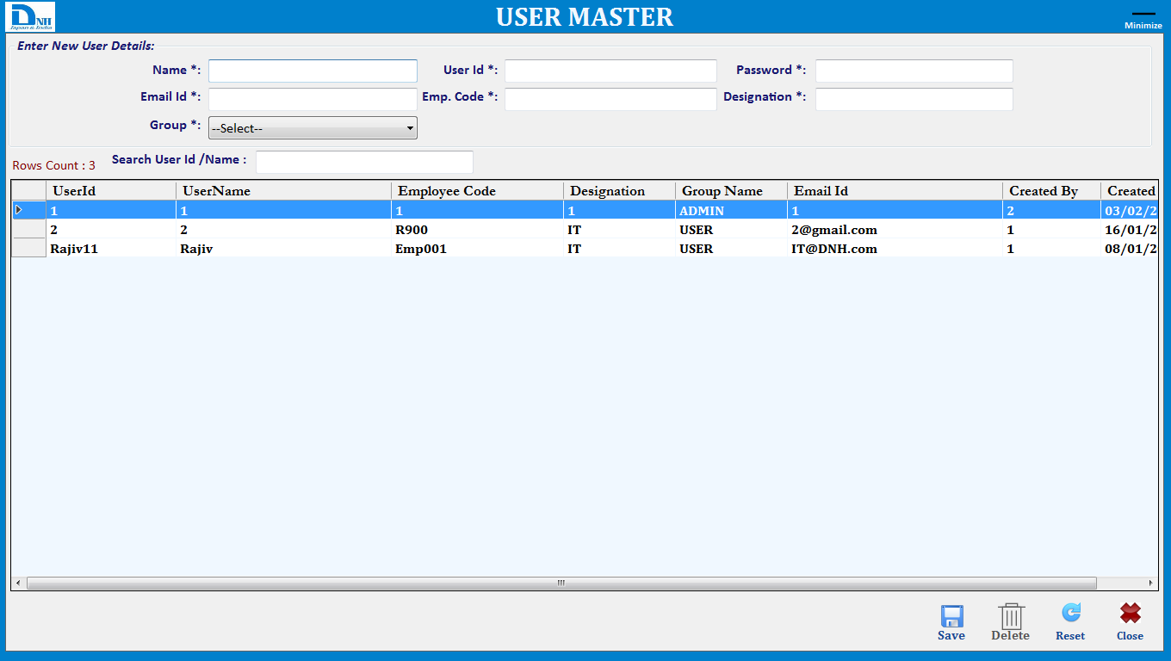

Brief Description: This screen is used to manage User via Save, Delete operations.
Note: UserId Will Be Unique.
Function Description in Detail:

Sr.No. | Function | Description | Remarks
1. | FORM LOAD | →During Form Load all data will be loaded in the Grid
2. | SAVE | →User will enter all details and click on save button to save the data.  →User will double click on any item in the grid to edit the data and click on save button to update the data.
3. | Delete | →User will double click on any item in the grid to select the data and click on delete button to delete the data.
4. | Reset | →It will clear all fields.

Group Master
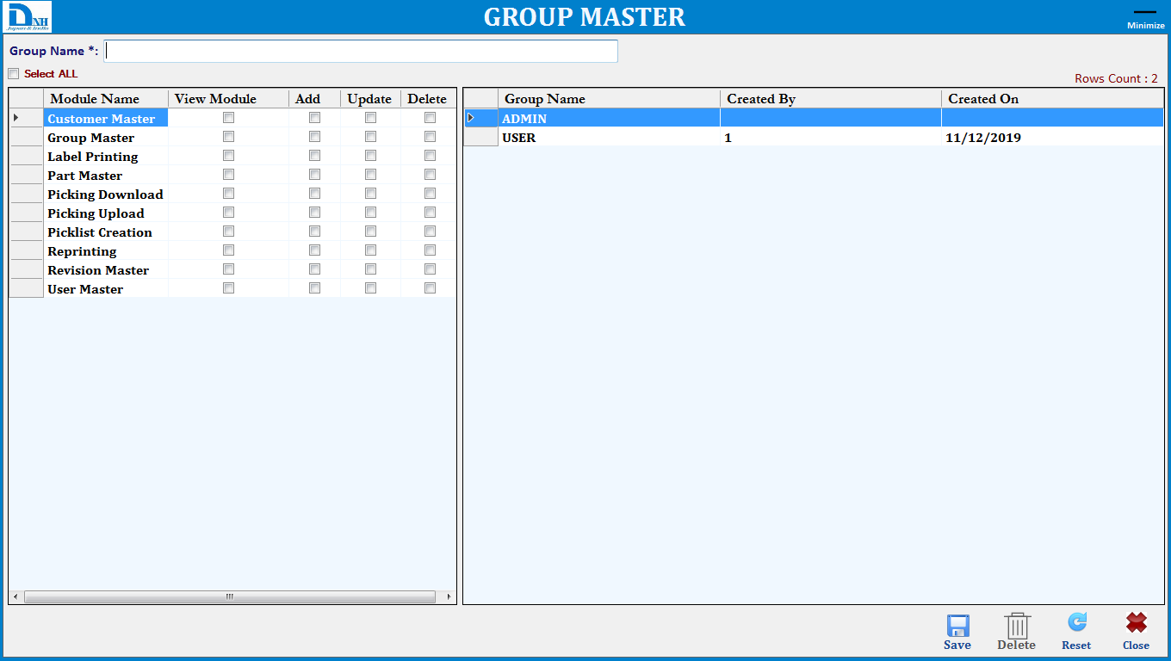

Brief Description: This screen is used to manage Group via Save, Delete operations.
Note: Group Name Will Be Unique.
Function Description in Detail:

Sr.No. | Function | Description | Remarks
1. | FORM LOAD | →During Form Load all data will be loaded in the Grid
2. | SAVE | →User will enter group name and select all the screen for which group has right and click on save button to save the data.  →User will double click on any item in the grid to edit the data and click on save button to update the data.
3. | Delete | →User will double click on any item in the grid to select the data and click on delete button to delete the data.
4. | Reset | →It will clear all fields.

Customer Master
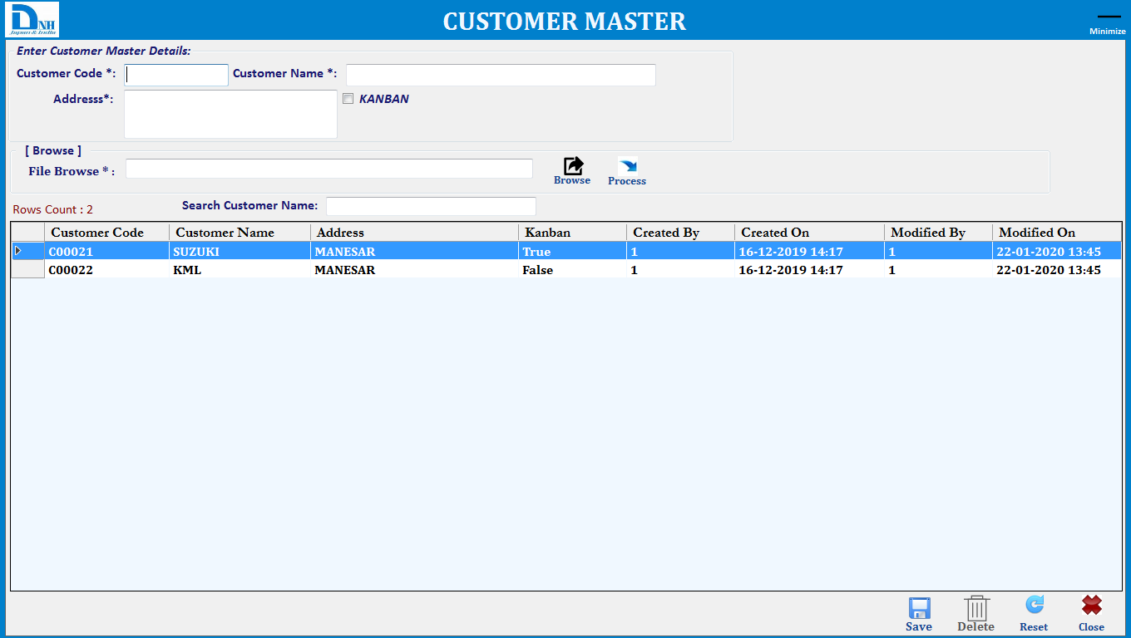

Brief Description: This screen is used to manage Customer via Save, Delete operations.
Note: Customer Code Will Be Unique.
Function Description in Detail:
Note:- Excel File Format should be Company Code (Column 1), Company Name (Column 2) , Address (Column 3),KANBAN (Column 4)(For Kanban Verification when it will be true).

Sr.No. | Function | Description | Remarks
1. | FORM LOAD | →During Form Load all data will be loaded in the Grid
2. | SAVE | →User will enter all details and click on save button to save the data.  →User will double click on any item in the grid to edit the data and click on save button to update the data.
3. | Delete | →User will double click on any item in the grid to select the data and click on delete button to delete the data.
4. | Reset | →It will clear all fields.
5. | Browse | →User can browse the customer raw data file and import one shot into database.

Part Master
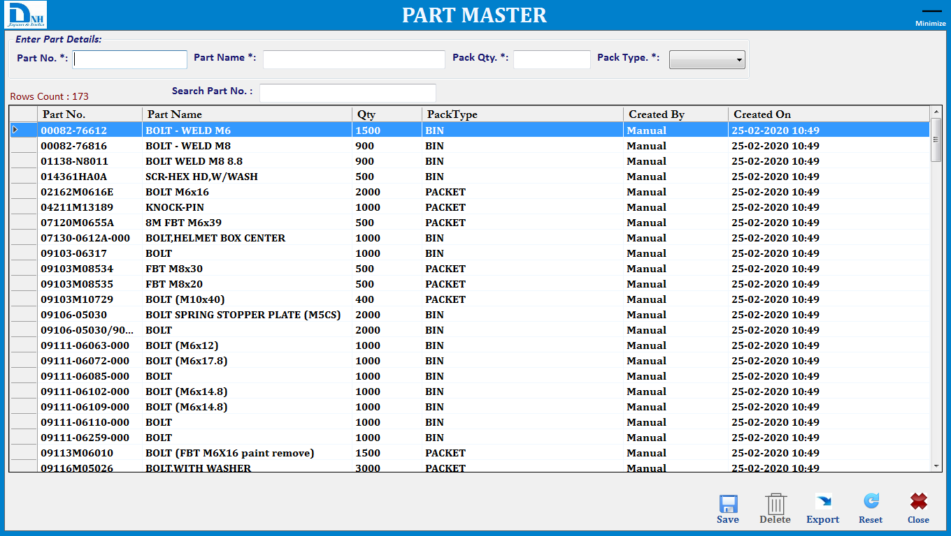

Brief Description: This screen is used to manage Part via Save, Delete operations.
Note: PartNo. Will Be Unique.
Function Description in Detail:

Sr.No. | Function | Description | Remarks
1. | FORM LOAD | →During Form Load all data will be loaded in the Grid
2. | SAVE | →User will enter all details and click on save button to save the data.  →User will double click on any item in the grid to edit the data and click on save button to update the data.
3. | Delete | →User will double click on any item in the grid to select the data and click on delete button to delete the data.
4. | Export | →User can export all part data into excel file.
5. | Reset | →It will clear all fields.

Revision Master
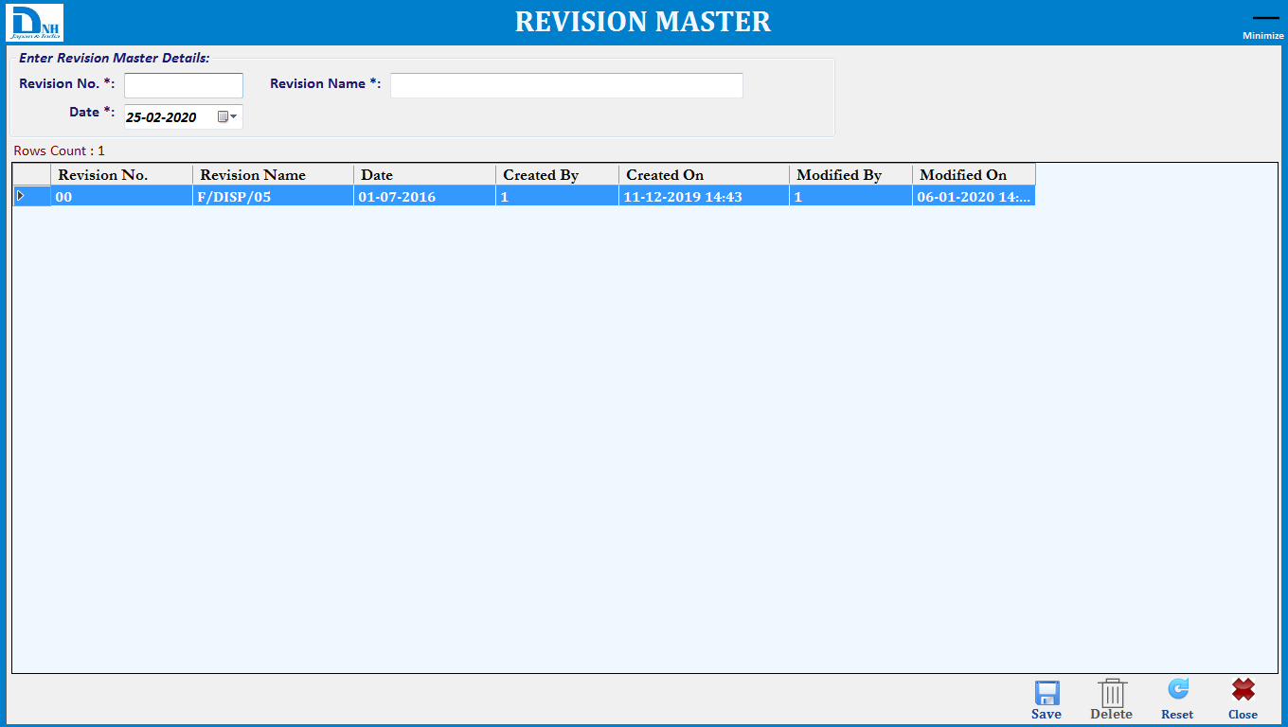

Brief Description: This screen is used to manage Revision via Save, Delete operations.
Note: Revision No. Will Be Unique and in this module user can enter only one revision entry at single time.
Function Description in Detail:

Sr.No. | Function | Description | Remarks
1. | FORM LOAD | →During Form Load all data will be loaded in the Grid
2. | SAVE | →User will enter all details and click on save button to save the data.  →User will double click on any item in the grid to edit the data and click on save button to update the data.
3. | Delete | →User will double click on any item in the grid to select the data and click on delete button to delete the data.
4. | Reset | →It will clear all fields.

Process

Label Printing
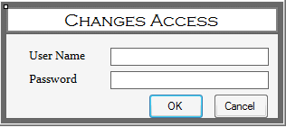

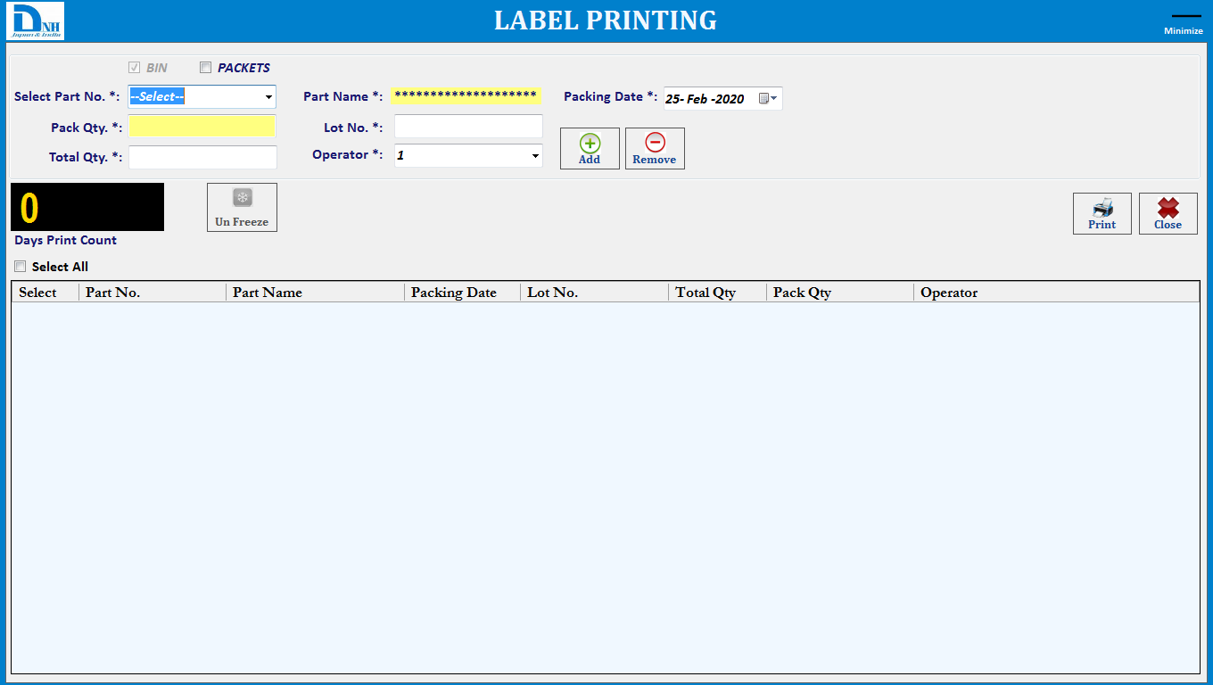

Brief Description: This screen is used to manage Print via Print operations.
Note: PartNo and Lot No combination Will Be Unique.
Function Description in Detail:

Sr.No. | Function | Description | Remarks
1. | Print | →All Label printing parameter will be freeze and supervisor click on unfreeze button then Changes Access screen will be display.  →Enter user id & password then.  →Part selection or any changes on the screen so supervisor/admin will enter password then can able to change the data and supervisor/admin information will be update into database.  →If default user admin/supervisor then all control will be unfreeze.  →User will select the Part No and Operator ,enter the Lot No, Total Qty and can modify the pack qty also then click on Add button (Add multiple part and start the printing).  →To Remove, Select line item from gridview click on remove button.  →By default, single Bin barcode will be print, when user want to print packet barcode also then need to check on packets checkbox.  →.User can scan multiple part from grid and will click on print button. System will calculate no. of labels (Based on total qty and part qty) labels and print accordingly.  →.Data will be Saved in database.
2. | Reset | →It will clear all fields.

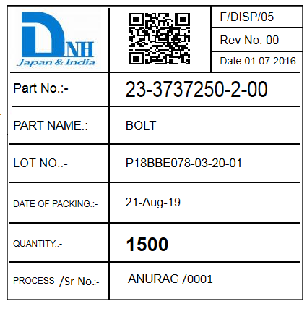

Note: 2D Barcode Data= PartNo~Qty~LotNo.~Date(DDMMYYYY)~4DigitSerialNo
23-3737350-2-00~1500~P18BBE078-03-20-01~21082019~0001

Re-Printing
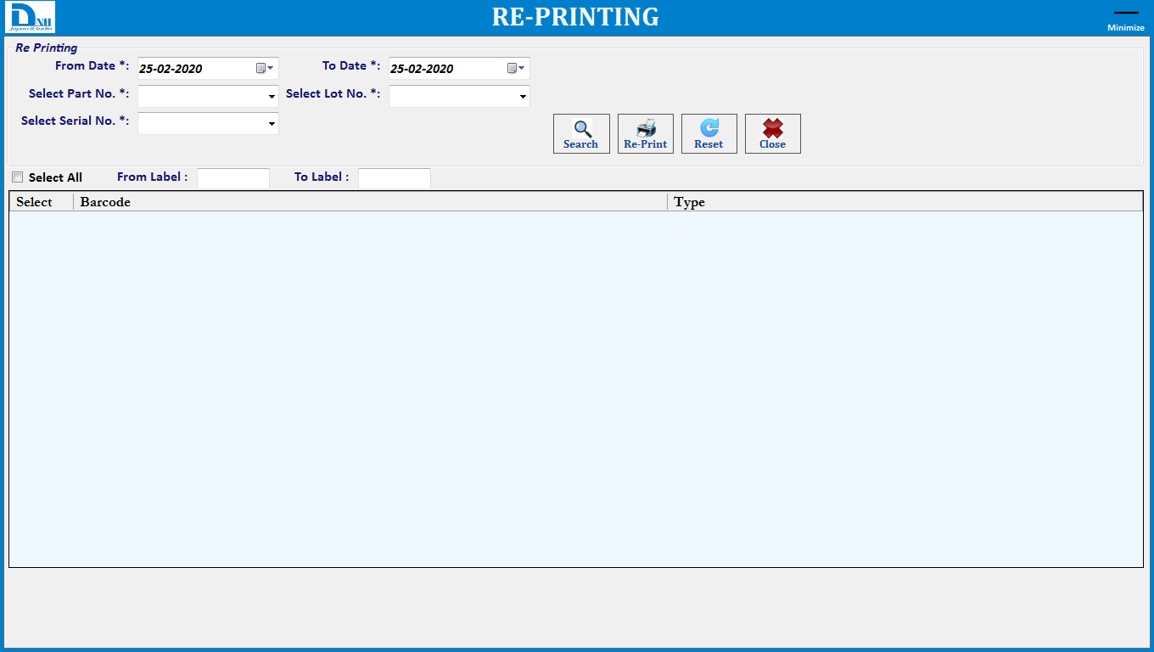

Brief Description: This screen for Re-Printing the Part barcode.
Function Description in Detail:

Sr.No. | Function | Description | Remarks
1. | Search | →User will select from date and to date, Part No, Lot No. or select the specific serial no ,From and To serial no.
2. | Reprint | →After click on search button, Data will be displayed in view and user will select the barcode and click on Re-print button.  →Data will be save into database.

Create Picklist No.
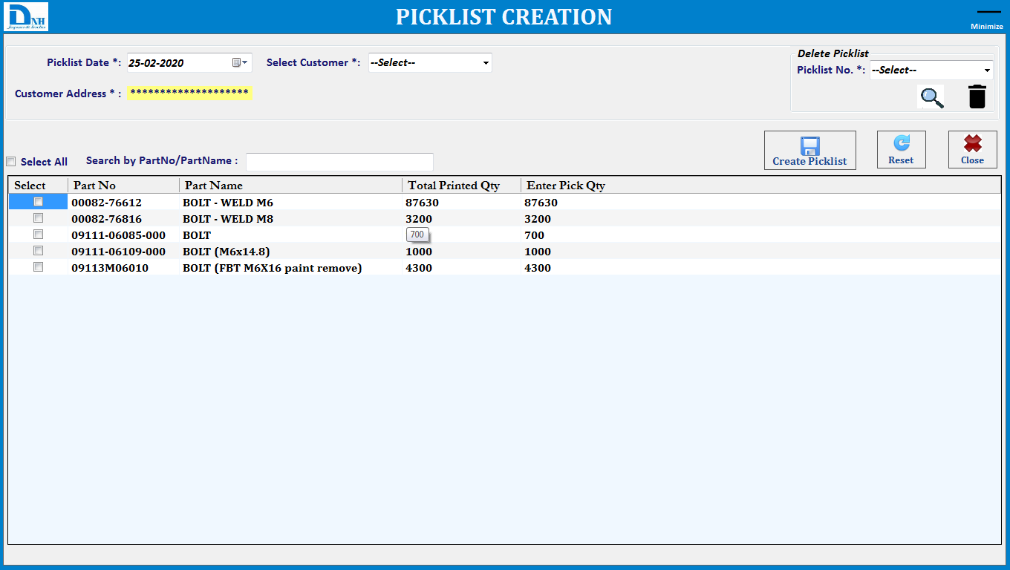

Brief Description: This screen is used to manage Import Picking file for picking operations.
Note: Customer wise pick list no. will be Unique.
Function Description in Detail:

Sr.No. | Function | Description | Remarks
1. | Create | →User will select specific details of customer and required part and Qty then Click one pick list no will generate.
2. | Search | →User can search specific part no for creating pick list and second search button for created pick list details.
3. | Delete | →Admin/Supervisor can delete the pick list until not in under transaction.
4. | Reset | →It will clear all fields.

HHT Upload Data
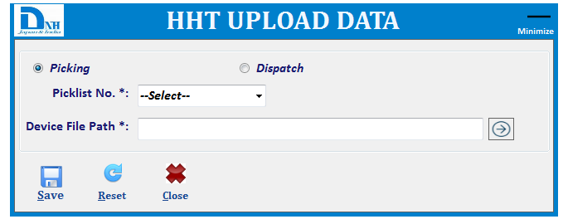

Brief Description: HHT Upload screen will be show like this.
- First, there will be two category (Picking and dispatch) of uploading pick list data.
- User will select the picklist and choose the HHT Upload file path and one file will be generate name with picklist no.
- User will copy all pick list files and manually past into HHT device into “DHN Picking Files” Directory.

HHT Main Menu
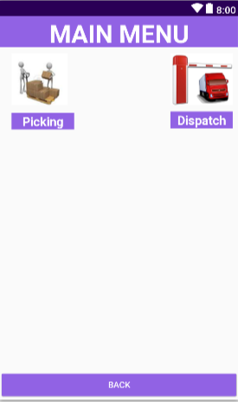
Brief Description: This screen will be two option in main menu:.

- Picking: - User will click on picking option then picking screen will be open.
- Dispatch: - User will click on dispatch option then dispatch screen will be open.

Picking
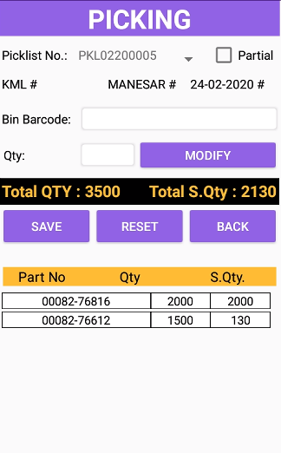

Brief Description: This screen will be used for Scanning.

- User will select Picklist No. then data will be display in view.
- Customer, Location and Picklist date will be show as below.
- User will scan the Bin barcode against the picklist data.
- Then scan qty will be update into view and displayed label and data will be save into database.
- In addition, Barcode data will be updated into HHT Picking Scan Files.
- When use want to scan partially then check on partial checkbox then admin QR Code will be scan then user can modify the Qty.

Validation Description:
- Picklist material and Qty will check with scanned barcode.
- If will not verified then below validation message display:

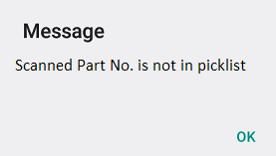
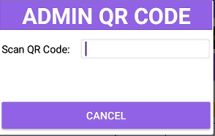
- Click on ok button then Input Box will be displayed and Admin/Supervisor will scan
barcode then further scanning will be start.

HHT Download Picking Data
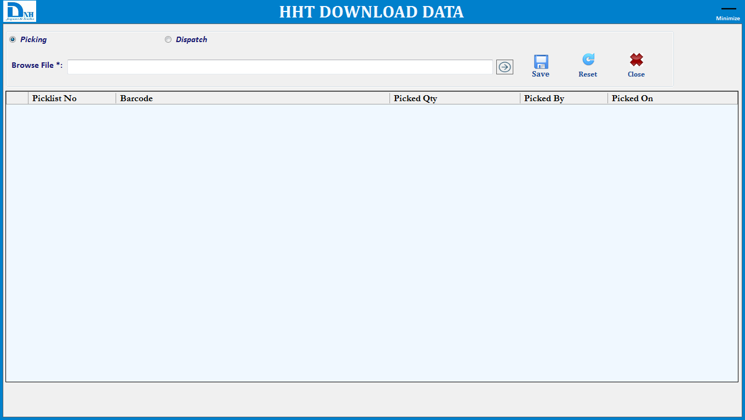

Brief Description: HHT Download will be screen show as above screenshot.
- First, There will two category(Picking and Dispatch) for download the files
- User will copy scanned files from HHT and paste into HHT Download Directory in PC startup path.
- Using this module, user will select the all scanned files and data will be display into view.
- Click on save button data will save into database.

Dispatch (Kanban Verification)
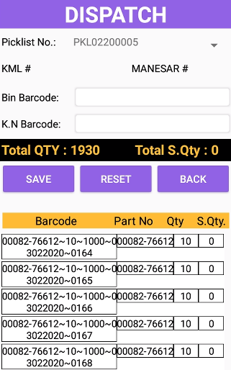

Brief Description: This screen will be used for Scanning.

- First user will scan Bin Barcode.
- Scan Kanban QR Barcode will marry of Bin Barcode data with PartNo. And Qty.
- Then Bin Barcode will be update in view
- In addition, Barcode data (Bin Barcode,Status,DispatchedBy,DispatchedOn) will be update into HHT Dispatch Scan File.

Validation Description:
- Scanned Bin barcode will verify Part and Qty with Kanban barcode.
- If will not verified then below validation message display:

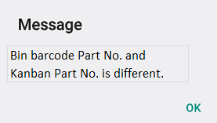

HHT Download Dispatch Data
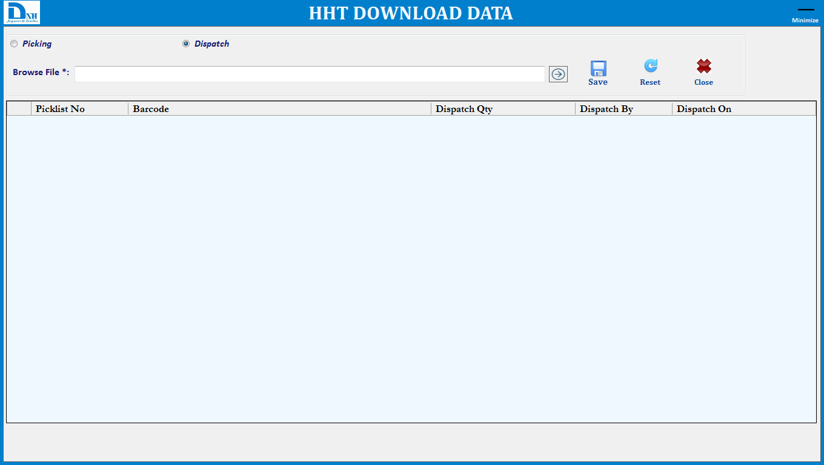

Brief Description: HHT Dispatch Download will be screen show as above screenshot.
- User will copy scanned files from HHT and paste into HHT Dispatch Download Directory in PC startup path.
- Using this module, user will select the scanned files and data will be display into view.
- Click on save button data will save into database.

Web Reports

Login
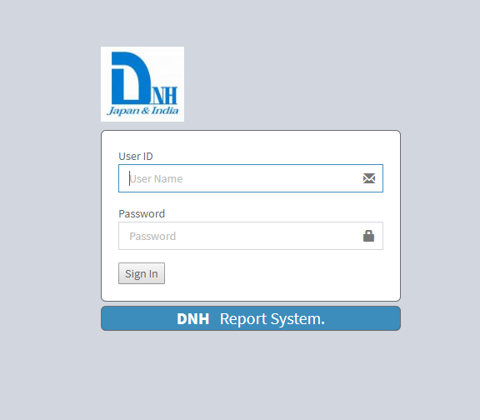

Brief Description: This screen is used for login purpose. User will enter User id & Password; system will validate entered user id & password from Application Database.

Report Main Menu
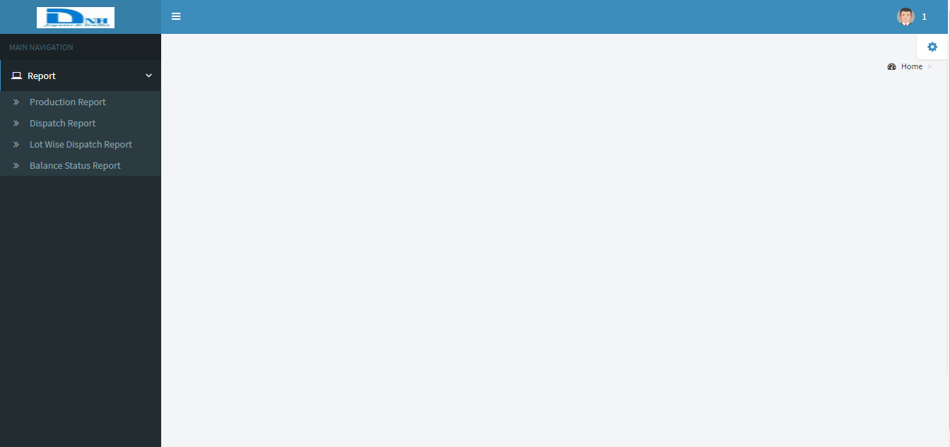

Brief Description: Main Navigation web report will be show:

Production Report
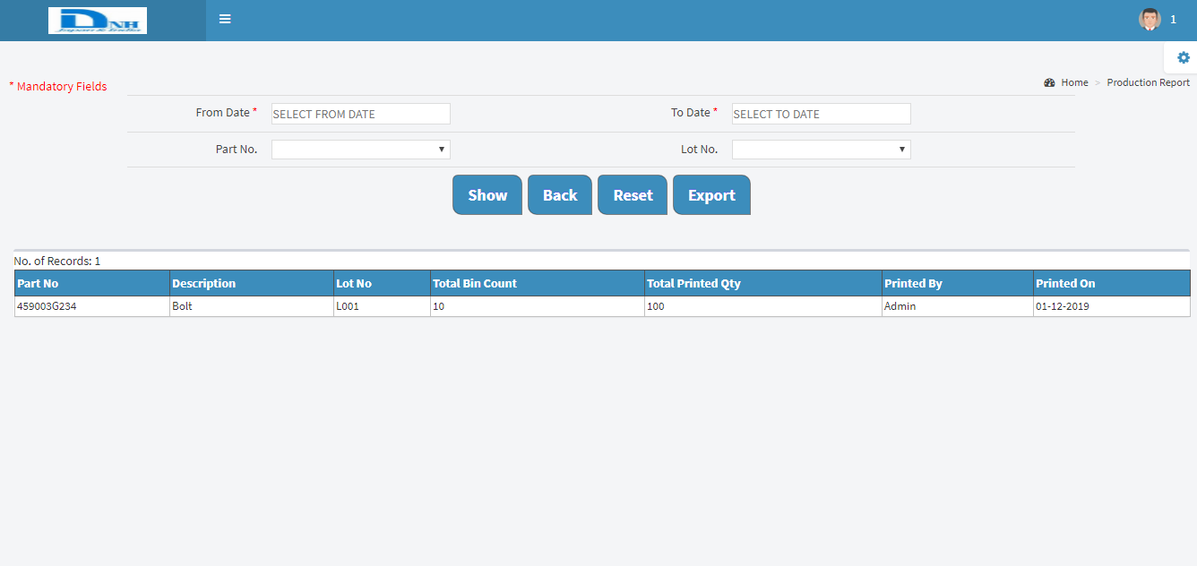

Brief Description: This report will show Printing Report related information.
- User will select from and to date then corresponding data will be display.
- Also can see Part No. and Lot No wise data will be display (Opt. Fields).

Dispatch Report
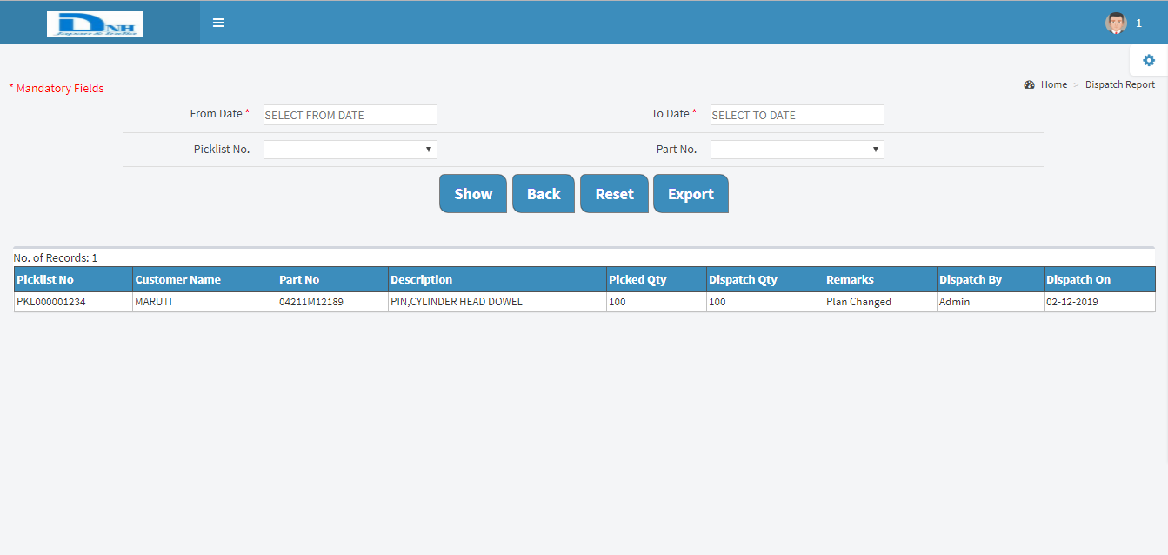

Brief Description: This report will show Dispatch Report related information.
- User will select from and to date then dispatch/Scanned data information will show.
- Also can see Picklist No. and Part No. wise data will be display (Opt. Fields).

Lot Wise Dispatch Report
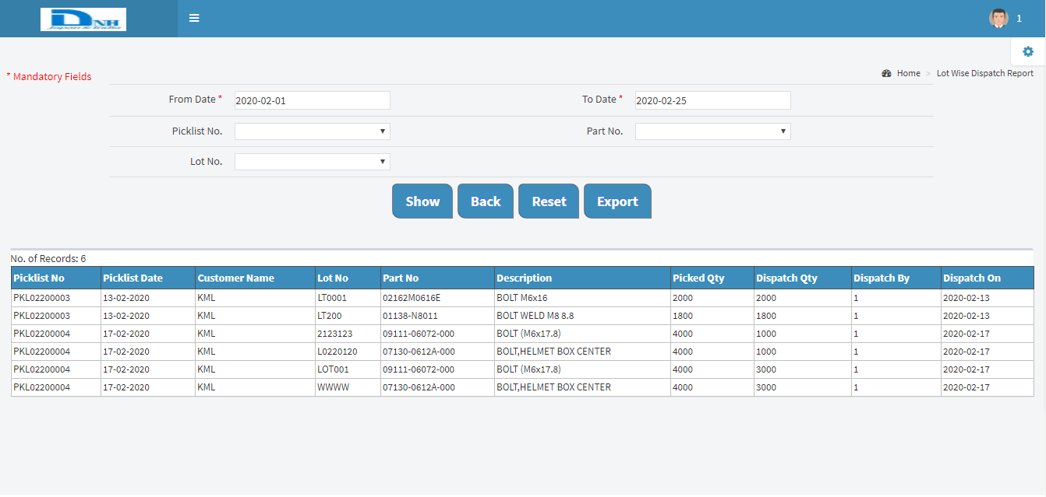

Brief Description: This report will show Lot Wise Dispatch Report related information.
- User will select from and to date then dispatch/Scanned data information will show.
- Also can see Picklist No. , Part No. and Lot No. wise data will be display (Opt. Fields).

Balance Status Report
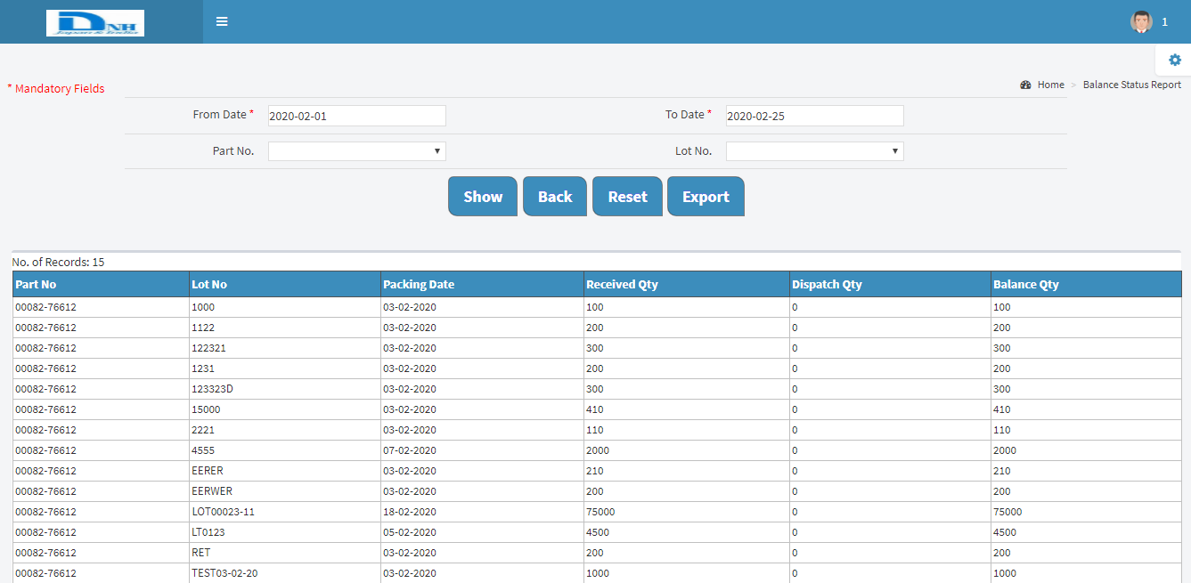

Brief Description: This report will show Balance Status Report related information.
- User will select from and to date then Printed and dispatch data information will show.
- Also can see Part No. and Lot No. wise data will be display (Opt. Fields).

